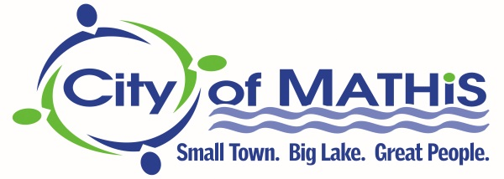

Mandatory Language for a Maximum Contaminant Level Violation
MCL, LRAA / TTHM

The Texas Commission on Environmental Quality (TCEQ) has notified the CITY OF MATHIS PWS #2050003 that the drinking water being supplied to customers had exceeded the Maximum Contaminant Level (MCL) for Total Trihalomethanes. The U.S. Environmental Protection Agency (U.S. EPA) has established the MCL(Maximum Contaminant Level) for Total Trihalomethanes to be 0.080 milligrams per liter (mg/L) based on locational running annual average (LRAA), and has determined that it is a health concern at levels above the MCL. Analysis of drinking water in your community for Total trihalomethanes indicates a compliance value on quarter Two 2018 of 0.105 mg/L for DBP2-01 and of 0.102 mg/L for DBP2-02.

Trihalomethanes are a group of volatile organic compounds that are formed when chlorine, added to the water during the treatment process for disinfection, reacts with naturally-occurring organic matter in the water. Some people who drink water containing trihalomethanes in excess of the MCL over many years may experience problems with their liver, kidney, or central nervous systems, and may have an increased risk of getting cancer.
You do not need to use an alternative water supply. However, if you have health concerns, you may want to talk to your doctor to get more information about how this may affect you.

We are taking the following actions to address this issue: The City of Mathis is working on a different chemical treatment scheme to mitigate the elevated formation of Total Trihalomethanes (TTHM), to correct the problem, as well as extensive water main flushing in the area.

Please share this information with all people who drink this water, especially those who may not have received this notice directly (i.e. people in apartments, nursing homes, schools, and businesses). You can do this by posting this notice in a public place or distributing copies by hand or mail.

If you have questions regarding this matter, you may contact Gary Paredez at 361-547-5951.
Posted / Delivered on: 8/31/2018

